OSINT4Fun Advent of OSINT 2024: Day 3

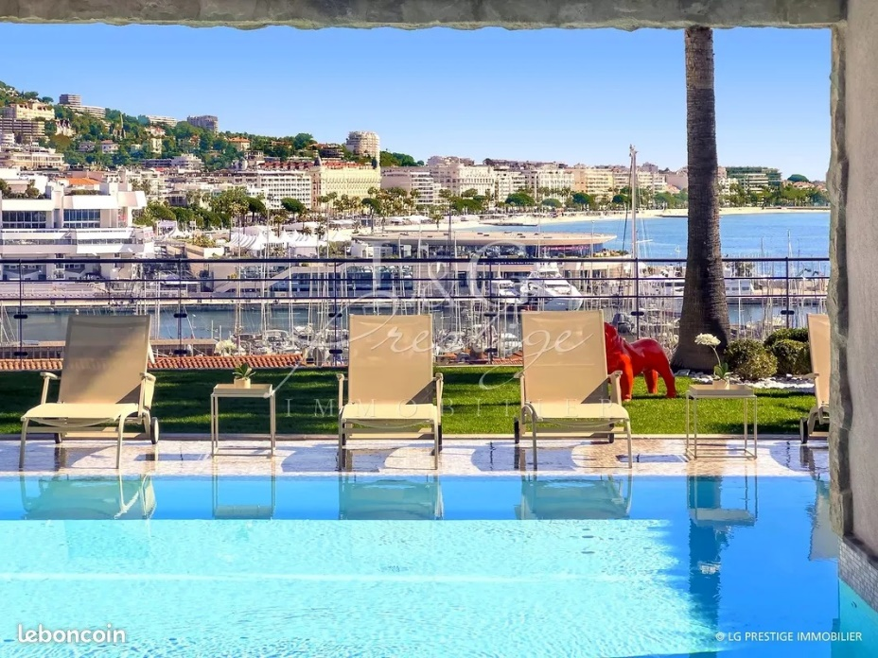

*This photo is part of a real estate agency's listing.*

*What is the address of this house?*

This picture contains some text that could be important. First, the watermark across the entire picture seems to say “L & G Prestige IMMOBILIER”. Then, on the bottom-right of the picture there is the text: leboncoin. Lastly, on the bottom-left of the picture is the text: LG PRESTIGE IMMOBILIER. We can thus probably assume that the real estate agency is called L & G Prestige Immobilier. Let’s keep that in mind while we do a Google reverse image search on the picture. The very first image is actually from the website of this real estate agency, so I open that page. I get presented with a map of Cannes. Scrolling down, I can see the properties this agency has listed in Cannes, with our image as the first result. This page does not give an exact address. However, again a map is shown with one house icon that points to an intersection of Boulevard Vallombrosa and Rue Georges Clemenceau. Before I start looking in Google Maps, I need to get an idea of what the property looks like. Going through the photos on the agency’s website, I can see that a pool and a stretch of grass are pointed towards the harbor with the sea on the right side. This suggests that the perspective of the photo for this challenge is directed towards the East. Now I am going to go back to Google Maps with the terrain layer to see if I can find a pool with a stretch of grass and perhaps a red dog on that grass. Specifically, the pool would be located East of the building. Although not really very near to the icon on the map of the agency’s page, I see one building with a pool that fits the search criteria just to the East of Musee des explorations du monde. Zooming all the way in, it looks like I can see sunbeds oriented towards the building, and what maybe looks like a red blob underneath a tree. To confirm, I want to see if I can get street view images of this house. With Google street view, I can only see the path on the back of the building, of which there are no photos on the website unfortunately. However, there are a number of 360-degree photos of the Musee des explorations du monde. Looking through these photos, we get a nice view from higher ground which enables us to take a glimpse into the garden of the suspected building. This way, I am able to see the specific fence that is shown on the picture, as well as the three palm trees mixed with smaller round bushes. And most importantly: a small red shape that resembles the dog sculpture! Now that I am confident I have the correct house, I return to Google street view which specifies this address as: 50 Rue Louis Perrissol.